SERIES discussion guide
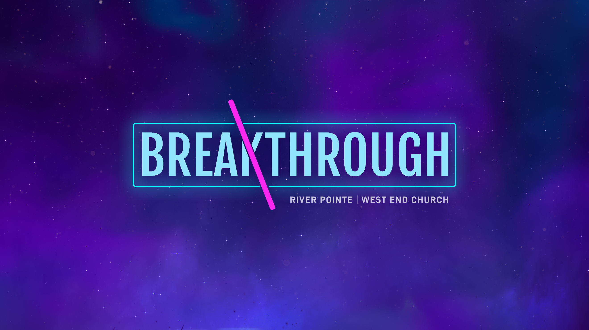
BREAKTHROUGH
ABE MATOS
MARCH 16, 2025
If you would like to watch the message, visit rpc.me/messages.

MESSAGE RECAP
In the final week of the Breakthrough series, we focused on a simple but powerful truth: Reading the Bible has the power to change your life.
Many of us want breakthrough—freedom from struggles, clarity in confusion, or healing from pain. But we often try to handle life’s challenges on our own, without tapping into one of the greatest resources available: God’s Word.
If we’re willing to trust the Bible for encouragement when life is hard, shouldn’t we also trust what it says about itself? The Bible isn’t just an ancient book filled with random stories. The Bible is living and active, breathed out by God, and a light to guide our path. Even a few minutes of reading the Bible daily can help us experience the peace, direction, or breakthrough we’re searching for.

WARM-UP QUESTION
- What’s a simple daily habit (like coffee, music, or scrolling your phone) that you can’t imagine living without?

DISCUSSION QUESTIONS
- Have you ever tried reading the Bible?
  - If yes, what was that like for you?
  - If no, what’s one reason it feels hard or intimidating to start?
- Abe compared reading the Bible to a boxer’s jab—simple, repetitive, but essential for success. How might reading the Bible consistently be similar to training in any other area of life?
- When life gets hard where do you usually turn for encouragement or guidance?
- Read 2 Timothy 3:16-17. How does the Bible distinguish itself from other sources of truth (like social media, books, podcasts)? (The Bible doesn’t just claim truth; it is the definitive truth inspired by God.)
- Do you think it’s possible for the Bible to still be relevant today? Why or why not? (Bonus: Abe mentioned the Bible remains the bestselling book of all time – even in the age of AI.)
- Read Hebrews 4:12. How does this verse describe the Bible, and in what ways does it challenge or encourage you personally?
- Abe’s wife said reading the Bible used to feel like “showing up to a movie late” – confusing and hard to follow. Can you relate to that feeling? What might make reading the Bible feel more approachable?
- Psalm 119:105 describes God’s word as a “lamp to my feet and a light to my path.” God’s word is a guide. Where in your life could you use more clarity or direction? How might regularly reading scripture help with that?
- Abe mentioned that sometimes we make breakthrough harder on ourselves by trying to do life without God’s guidance. What comes up for you when you think about starting your day with a rhythm of reading the Bible?

APPLICATION QUESTION
- Abe challenged us with this: If the Bible is God’s truth, breathed out by Him and meant to guide us—why wouldn’t we want to read it?
  - What’s one small step you could take this week to start reading the Bible or read it more consistently? (Ideas: Download the YouVersion Bible app, read for 5 minutes a day, start a simple reading plan, ask a friend to read with you.)
    - Resource link to Abe’s Bible Reading Plan

SUMMARY
- Read your Bible. The Bible is God’s truth for your life.
- Breakthrough is harder when we try to navigate life without God’s guidance.
- You don’t have to understand everything – God will meet you in the process.
- Don’t go it alone—invite someone to read with you and encourage each other along the way.

CLOSING PRAYER
Your closing prayer can include:
- Gratitude – Thank You, Lord, for this time together to study Your Word.
- Acknowledgment of new insights – We are grateful for the wisdom You have given us today.
- Request for guidance – As we go into our week, help us remember what we’ve learned and give us the courage to obey Your calling. Amen.

